High Level Design (HLD)

Analyzing Swiggy : Bangalore delivery outlet data

Submitted By :

CHANNABASAV ANGADI

# Document Version Control

|  |  |  |  |
| --- | --- | --- | --- |
| **Date Issued** | **Version** | **Description** | **Author** |
| **06 Mar 2022** | 1.0 | Analyzing Swiggy : Bangalore delivery  outlet data | Channabasav Angadi |
|  |  |  |  |

**Contents**

Document Version Control 2

Abstract 3

1 Introduction 5

1.1 Why this High-Level Design Document? 5

1.2 Scope 5

2 General Description 6

2.1 Product Perspective & Problem Statement 6

2.2 Tools used 6

3 Design Details 7

3.1 Functional Architecture 7

3.2 Optimization 8

4 KPIs 9

4.1 KPIs (Key Performance Indicators) 9

5 Deployment 9

# Abstract

The online food ordering market includes foods prepared by restaurants, prepared by

independent people, and groceries being ordered online and then picked up or delivered.

The first online food ordering service, World Wide Waiter (now known as Waiter.com),

was founded in 1995. Online food ordering is the process of ordering food from a website

or other application. The product can be either ready-to-eat food or food that has not been

specially prepared for direction consumption.

# Introduction

## Why this High-Level Design Document?

The purpose of this High-Level Design (HLD) Document is to add the necessary detail to the current project description to represent a suitable model for coding. This document is also intended to help detect contradictions prior to coding, and can be used as a reference manual for how the modules interact at a high level.

The HLD will:

* Present all of the design aspects and define them in detail
* Describe the user interface being implemented
* Describe the hardware and software interfaces
* Describe the performance requirements
* Include design features and the architecture of the project • List and describe the non-functional attributes like:

o Security o Reliability o Maintainability o Portability o Reusability o Application compatibility o Resource utilization o Serviceability

## Scope

The HLD documentation presents the structure of the system, such as the database architecture, application architecture (layers), application flow (Navigation), and technology architecture. The HLD uses non-technical to mildly-technical terms which should be understandable to the administrators of the system.

# General Description

## Product Perspective & Problem Statement

The online food ordering market includes foods prepared by restaurants, prepared byindependent people, and groceries being ordered online and then picked up or delivered.The first online food ordering service, World Wide Waiter (now known as Waiter.com),was founded in 1995. Online food ordering is the process of ordering food from a websiteor other application. The product can be either ready-to-eat food or food that has not beenspecially prepared for direction consumption.

## Tools used

Power Bi



# Design Details

## Functional Architecture

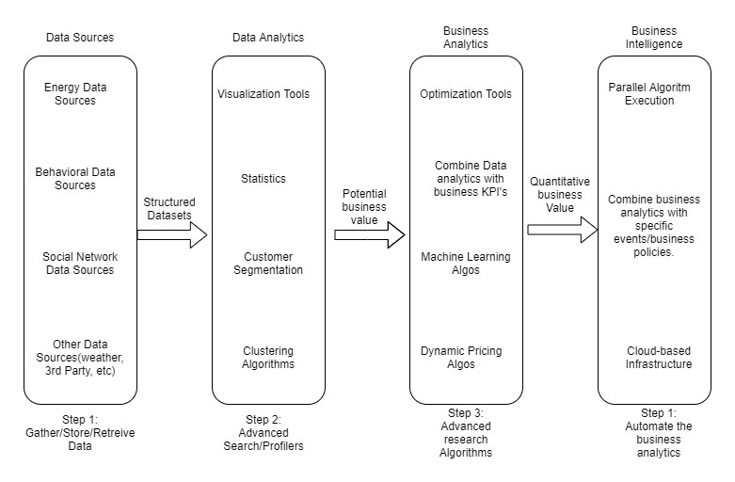

Figure 1: Functional Architecture of Business Intelligence

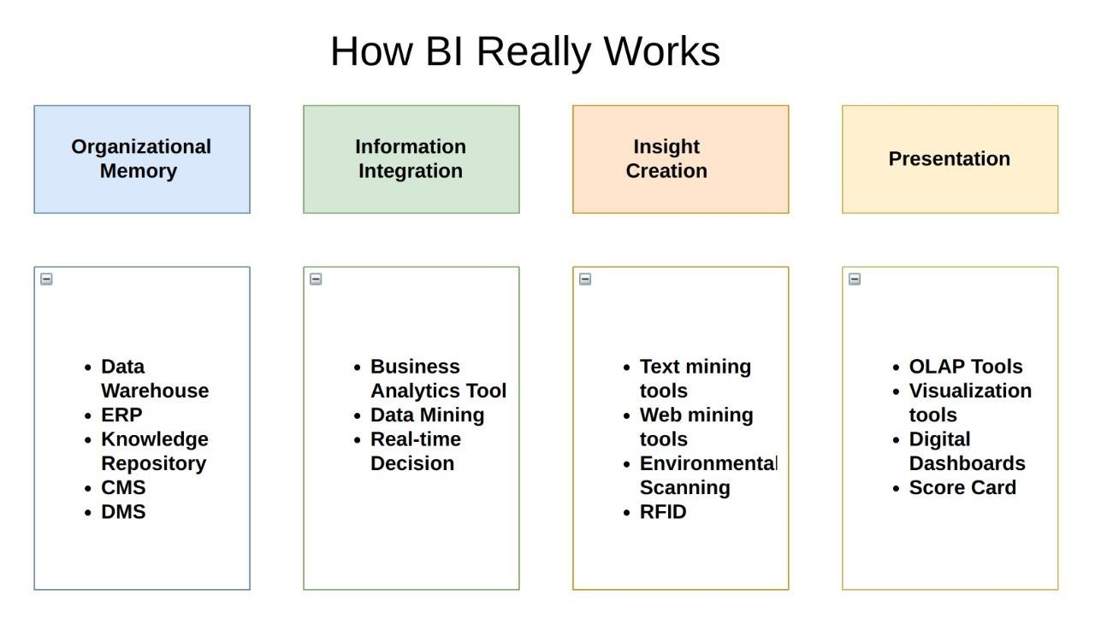

## Optimization

#### Your data strategy drives performance

* Minimize the number of fields
* Minimize the number of records
* Optimize extracts to speed up future queries by materializing calculations, removing columns and the use of accelerated views

#### Reduce the marks (data points) in your view

* Practice guided analytics. There’s no need to fit everything you plan to show in a single view. Compile related views and connect them with action filters to travel from overview to highly-granular views at the speed of thought.
* Remove unneeded dimensions from the detail shelf.
* Explore. Try displaying your data in different types of views. **Limit your filters by number and type**
* Reduce the number of filters in use. Excessive filters on a view will create a more complex query, which takes longer to return results. Double-check your filters and remove any that aren’t necessary.
* Use an include filter. Exclude filters load the entire domain of a dimension, while include filters do not. An include filter runs much faster than an exclude filter, especially for dimensions with many members.
* [Use a continuous date filter.](http://onlinehelp.tableau.com/current/pro/online/mac/en-us/help.htm#filtering_add_dragfields_dates.html) Continuous date filters (relative and range-of-date filters) can take advantage of the indexing properties in your database and are faster than discrete date filters.

# KPIs

Dashboards will be implemented to display and indicate certain KPIs and relevant indicators for the disease.

As and when, the system starts to capture the historical/periodic data for a user, the dashboards will be included to display charts over time with progress on various indicators or factors

* What is top rated Reasturent
* What is mot most famous location
* Search by Reasturent and see what food they serve
* Low Rated Reasturent

## KPIs (Key Performance Indicators)

Key indicators displaying a summary of the Housing Price and its relationship with different metrics

* What is top rated Reasturent
* What is mot most famous location
* Search by Reasturent and see what food they serve
* Low Rated Reasturent

# Deployment

Prioritizing data and analytics couldn’t come at a better time. Your company, no matter what size, is already collecting data and most likely analyzing just a portion of it to solve business problems, gain competitive advantages, and drive enterprise transformation. With the explosive growth of enterprise data, database technologies, and the high demand for analytical skills, today’s most effective IT organizations have shifted their focus to enabling self-service by deploying and operating Power BI at scale, as well as organizing, orchestrating, and unifying disparate sources of data for business users and experts alike to author and consume content.

Power BI prioritizes choice in flexibility to fit, rather than dictate, your enterprise architecture. Power BI Server and Power BI Online leverage your existing technology investments and integrate into your IT infrastructure to provide a self-service, modern analytics platform for your users. With on-premises, cloud, and hosted options, there is a version of Power BI to match your requirements. Below is a comparison of the three types:

TYPE PROS CONS

### Power BI

* Full control of hardware and software
* Infrastructure and data remain behind your firewall
* Need dedicated administrators to manage hardware and software
* Additional infrastructure needed to access off-network (mobile, external)

Depending on your organizational roles and responsibilities, Power BI Server should be installed by a systems administrator and the designated Power BI Server Administrator in coordination with the appropriate IT roles. For Power BI Online, you will integrate with your existing technology and configure the site settings. The Data & Analytics Survey, completed by business teams, identifies and prioritizes data use cases, audience size, and users. You will use the information collected in both surveys to plan your deployment strategy, including sizing, installation, and configuration of your Power BI Server or integration and configuration of Power BI Online. In addition to installing Power BI Server or configuring Power BI Online, administrators will also need to plan for the client software installation of Power BI Prep Builder, Power BI Desktop, Power BI Mobile, and Power BI Bridge for Power BI Online where applicable.